V-Chiller connection to internet instructions

# Step 1. Turn on the machine and wait for the screen to show the following desktop:

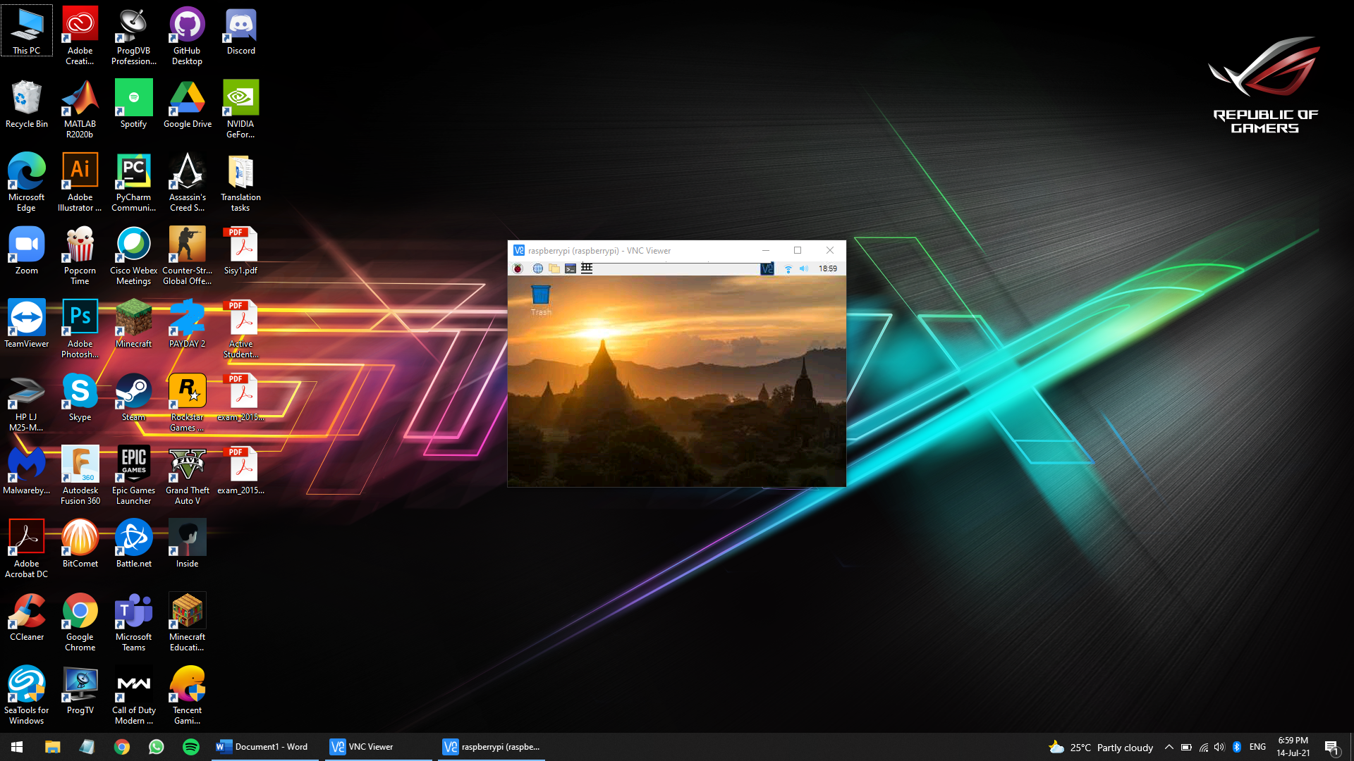

# Step 2. Click on the WIFI symbol on the top right of the screen on the taskbar (shown in the previous screenshot) to show the WIFI networks in the area as shown here:

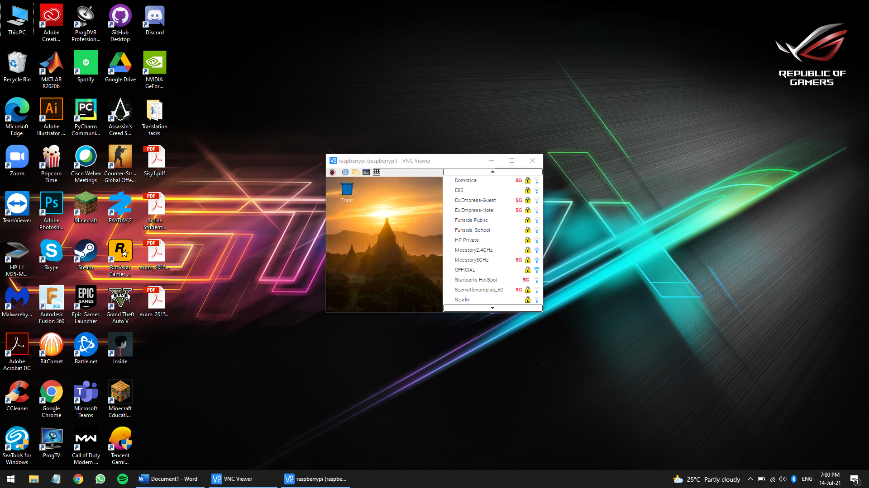

# Step 3. Click on the desired WIFI network you wish to connect to type the security key:

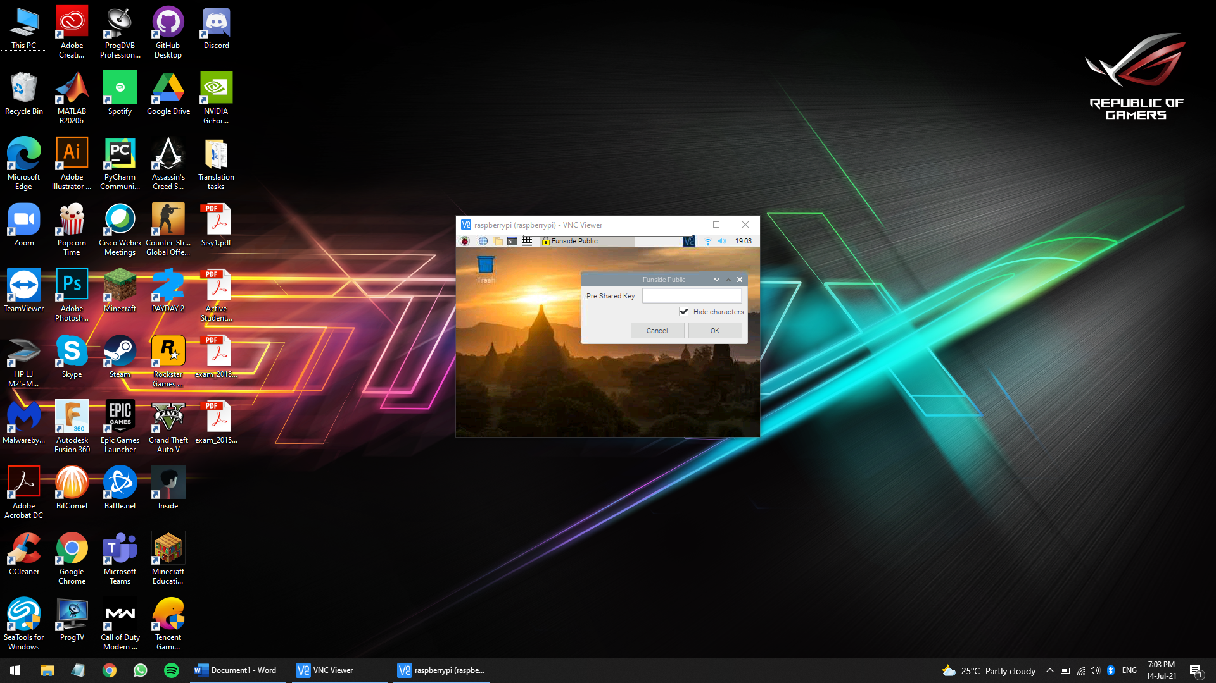

# Step 4. To type the network key, press on the keyboard icon on the topleft part of the screen on the taskbar and type it. Press the OK button to confirm entry

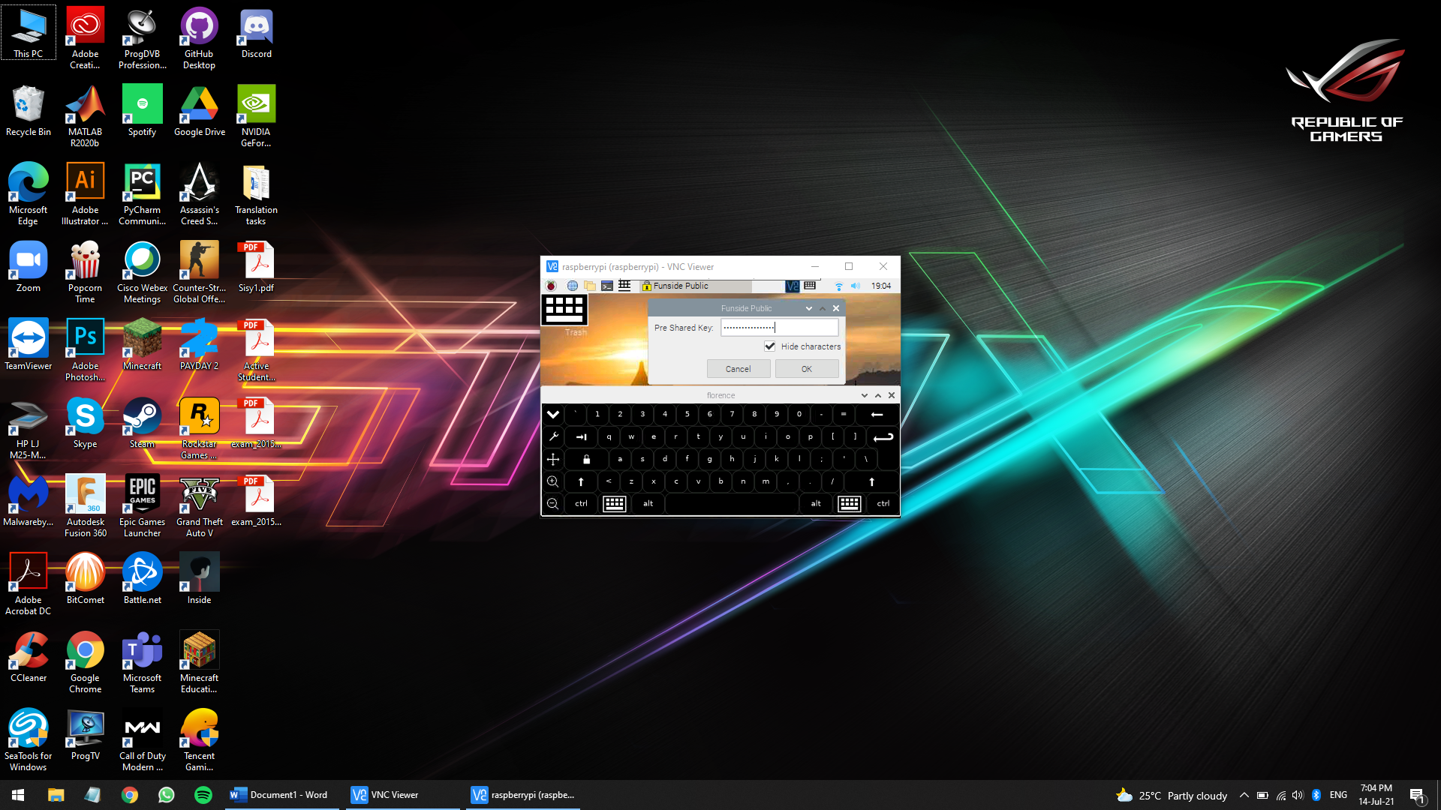

# You should then see the following WIFI symbol if you have successfully connected.

